Introduction

Purpose & Scope of this document

The purpose of this document is to outline the steps that will be taken to solve the problem and to understand the component design of the model and its usages. This document also includes the design of the elements and the workflow of the model.

Component Design

Component design diagram

This part should explain about the component design and why the specified parts of the model are designed in that specific way. This part should showcase the Sequence diagram, class diagram and the flowchart for the overall function.

Overall Workflow

E.g., Sample diagram below is for the encryption

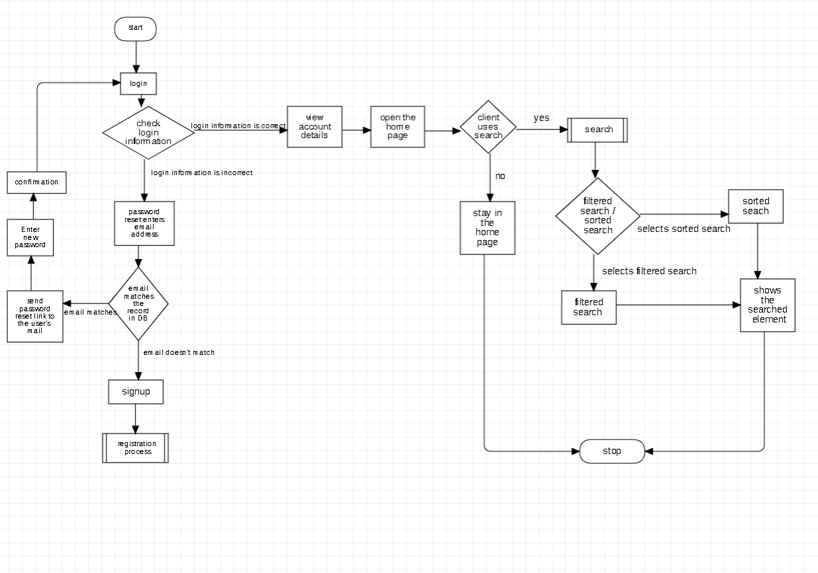

Sample Sequence diagram for the user to login as below:

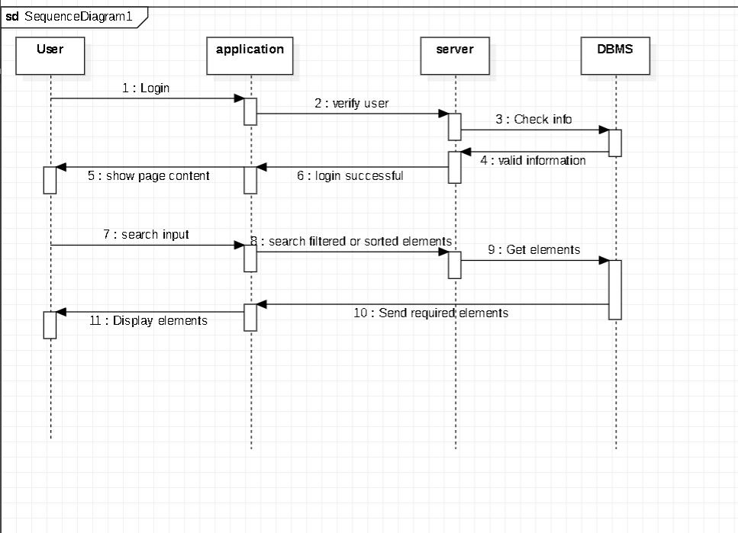

LOW LEVEL DESIGN

This part will explain the details about the end-to-end workflow of the model with hidden level method details.

Below is the sample diagram:

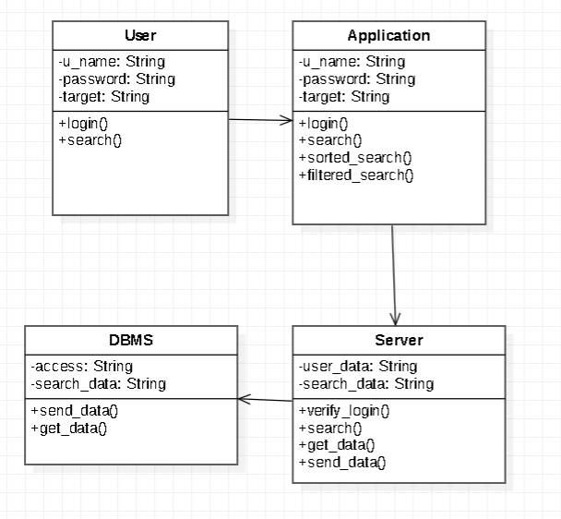

Technology & Framework used in the model

This part shows the list of the Technologies and Frameworks that are used in the model for designing and testing.

E.g.

1. ReactJS

2. Mongo DB 6.0

3. HTML

4. CSS, Java Script

Solution Approach

This part will provide with the detailed view of how the functions and responsibilities of the model and how the assigned components of the model work

1. We need to create a Dynamic UI agent similar to the outline of the design diagram.
2. The UI agent will have the responsibilities of the component of the model.
3. The UI engine will use the information stored in the JSON format for the html tags.
4. This component will further act as the interacting part of the model.
5. This component will be created as the self-dependant model.
6. We will create a sample test application and it will show the software behaviour to the given model.
7. This model will be created with react so it can interact with the user with some simpler functions and it can be easily handled.
8. The UI is in in dynamic so it will be complex so it is important to constantly optimize the application to make it more responsive and scalable.
9. Finally in the design there could be some errors and bugs these could be removed or fixed using the test and debugging method.